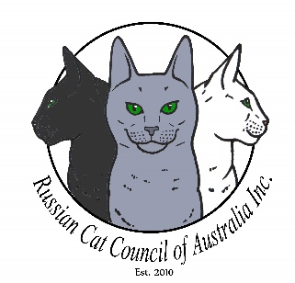
Russian Cat Council of Australia Inc.
RENEWAL MEMBERSHIP
Renewal due date – 1st December.

Name:
Address:
 |  |  |  | Post Code:
Mobile:
Email: |  | Website:
Facebook:
Membership Number:
MEMBERSHIP TYPE:
Are you a breeder/retired breeder | ☐ |  | Please tick the applicable box
Pet Owner | ☐
Please tick one of the membership categories below.
Single $25 - Eligible for 1 Vote | ☐ |  | Breeders are listed on the RCCA Inc website on the “Breeders Listing”
Double $40 - Eligible for 2 Votes | ☐
Associate $20 - Non-voting | ☐ |  | Pet owner.

- Members who are not financial by the date of the AGM are not eligible to vote.
- Please notify the Membership Secretary if there is any changes to your online listing.
Email completed form along with proof of payment to the Membership Secretary.
Maree Carle tlcpets@iinet.net.au

Direct Deposit: Commonwealth Bank BSB: 062 452 Account:10252535
Please enter your surname in description when paying by direct deposit

OFFICE USE:
Date Received: | Click here to enter a date.
Form of Payment Received. | Cash☐ Cheque ☐ Direct Deposit ☐
Membership Secretary Signature:
Copy forwarded to | President ☐ Secretary ☐ Treasurer ☐ Public Officer ☐

Updated:4/5/2020

